LOCATION:

The Centre for Learning, Organic Agriculture and Appropriate Technology (CLOAAT) is a campus of 100 acres located in a beautiful and quiet green valley just 18 kms from Kodaikanal. The Centre includes an Organic Farm and is unique in that we have intentionally no connection to the Tamil Nadu electricity grid and no intention to do so in future. All our electricity is supplied by 89 Solar Electric Panels, a Micro-hydro plant and a Wind-generator.
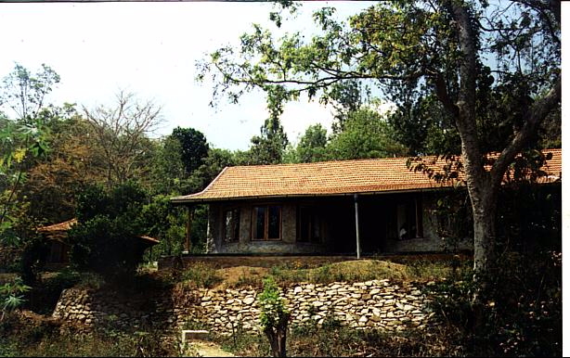
We also have 7 large Biogas plants that fuel our kitchens, the Science Lab’s Bunsen burners and power a dual-fuel engine. We have 5 Solar Hot Water Heaters, necessary because CLOAAT is cool in the winter (minimum temperature 9ºC), located at 1140 metres (3800 ft) altitude.

In 2008, CLOAAT, received the prestigious Model Green Schools Award, from the well known New Delhi NGO: Centre for Science and Environment. Our “low-carbon dioxide”, eco-friendly energy- saving water conservation measures, “zero-waste” recycling programme, minimal air pollution and care for the bio-diverse terrain, were all monitored and graded. The Farm is certified Organic by Control Union, based in the Netherlands.

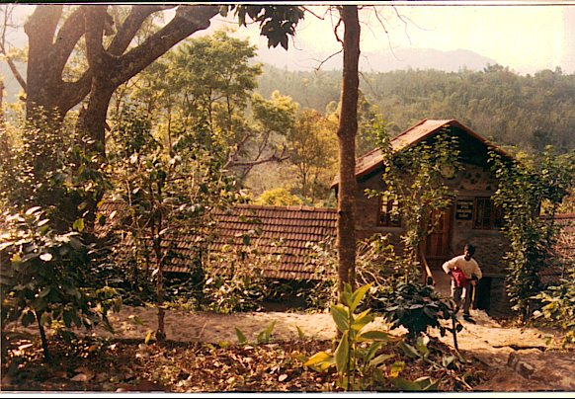

LEARNING:

We take students in the age range of 18-28 years who already have a good mastery of English. (We also run a Senior Secondary School, Sholai School). We like to meet the parents and their wards for interview, seeking out those who will value our educational approach and share our concern for Planet Earth.

The Principal, Brian Jenkins B.A (Hons), Sussex University, worked at the J. Krishnamurti Educational Centre, Brockwood Park in UK for 14 years and knew J. Krishnamurti well. Hence although there is absolutely no guru-worship or following of J. Krishnamurti at CLOAAT, discussions on the cruciality of watching oneself in ones relationships with other human beings and Nature, form an important aspect of our work here.

We are also much concerned that the students should study meaningfully and with serious application to improve their knowledge and grasp of their chosen subjects. Students at this age should have developed the necessary learning skills to study of their own interest and passion, but we do find that some of them have lacunae, which require individual attention. This we give and we also provide the right learning environment for the Mature Students to have all necessary future life skills.

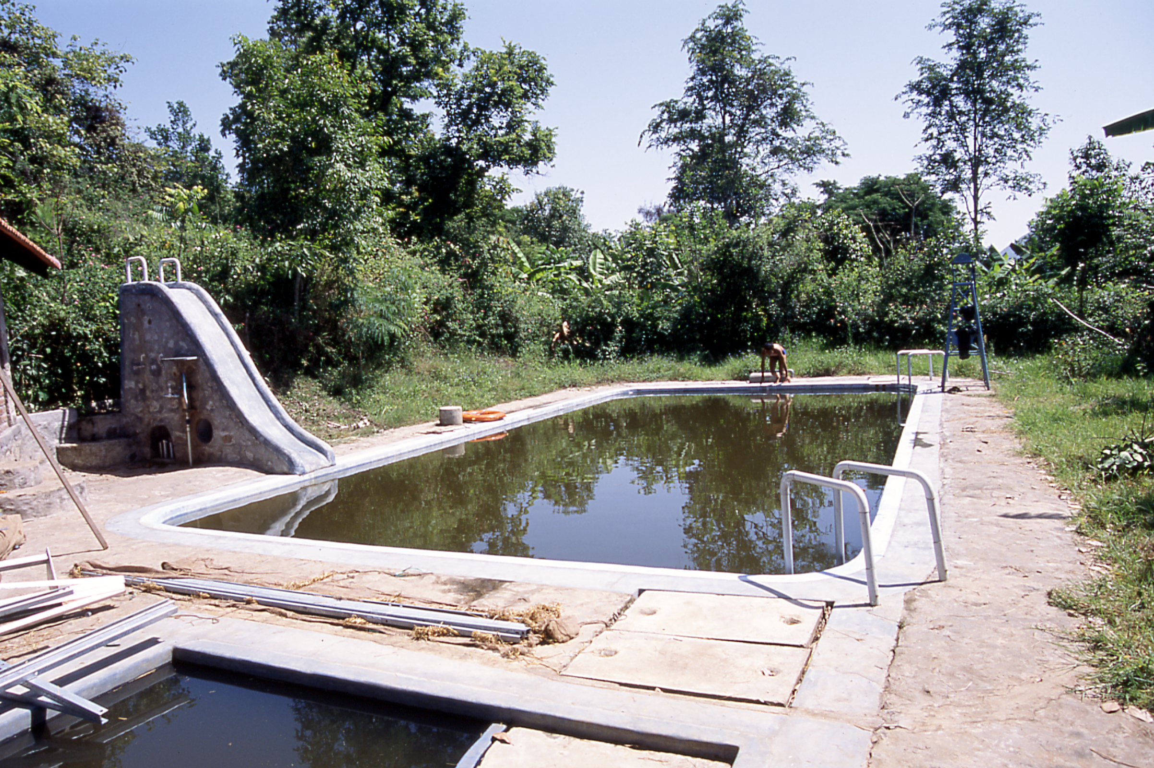
THE COURSES: CLOAAT is not a commercial organisation. Our deep concern is to educate, that is to bring out the very best in young people so that they understand themselves and understand the World; allowing them to discover an ability to tackle relationships of all kinds. They will also acquire a fluent mastery of English enabling them to handle the courses below with serious application and enquiring minds.
The subjects we offer include:

- Understanding Knowledge
- Philosophical Explorations
- Environmental Management
- The Art of Teaching
- English Literature
- Organic Farming
- Appropriate Technology
- Practical Engineering and Design
- Hatha Yoga and other Alternative Health Practices
- Art

CLOAAT is an International Examination Centre for the University of Cambridge, but for the Mature Student Programme, we do not encourage the taking of examinations. In India, Examinations are a national neurosis, putting the brakes on learning and preventing young people from exploring what they really love to do in life.

At the end of the programme the Mature Student will be issued a Certificate outlining what he/she has learnt and his/her capabilities
and abilities. If required we will assist the Mature Student in finding a placement for his/her future life.

THEORY AND PRACTICE: E.F. Schumacher, the Father of the Appropriate Technology and the Green Economics movement, who wrote “Small is Beautiful” ofttimes declared that the one year he spent working on an Organic Farm, played a crucial role in his understanding and creation of a new approach to Economics.

Dr. Narayana Reddy, one of our Trustees, and a pioneer in Organic Agriculture in India also states that meaningful theoretical knowledge requires study, hands-on practical experience and a creative spirit.

Every year from our Universities in India, lacs of scientific papers are written on schemes to benefit the poor, rural and urban. But rarely do we see “realization”. Here at CLOAAT we are exploring what it means to be creative. Do come to see for yourself. The students learn through studying, taking responsibility for the Centre and through applying themselves to challenging projects.

THE INFRASTRUCTURE: To date we have spent more than Rs. 9 Crores on building up the infrastructure of Appropriate Technologies (solar, micro-hydro, bio-gas and wind), eco-friendly buildings, and the organic farm, to provide a sustainable Learning Centre where the students can research, engage and study.

THE PSYCHOLOGICAL ATMOSPHERE:

J. Krishnamurti made clear the importance of understanding ones conditioning, the pervasive destructive self-centredness in ourselves and in the World and the cruciality of watching desire and all its manifestations.

Hence at CLOAAT, students know that smoking, drinking and the taking of narcotic drugs are definitely not allowed. We lay down few rules because we believe that sensitivity should be paramount. Hence the students behave well, showing respect for one another’s space and learning to listen to one another and the faculty members with genuine respect and not out of obedience. They are encouraged to organise their own activities in Sports, Drama, Theatre Workshops, Hiking, etc.. However the faculty are clear that they should not waste their time but should apply themselves to a serious regime of hard work and study.

Cleanliness of ones body and clothing, reasonably smart clothes and orderliness in ones room are understood to be an obvious requirement.

THE FUTURE:

At the completion of their course, our graduating students may choose to join the J. Krishnamurti Educational Centre, Brockwood Park, in UK.

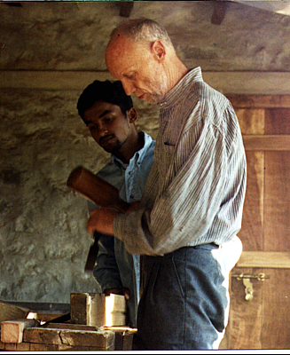
At the same time we want parents to understand that the time their wards spend at CLOAAT is more than anything a time for them to mature psychologically. Hence they will have here an opportunity to reflect and discuss what their chosen vocation in life should be, a worthwhile vocation that they will really love to do. Of course we are not blind to the importance of having financial security in life. Therefore we see it as our clear responsibility to help the Mature Students, after they leave to go out into World with a clear sense of purpose, being pragmatic and yet choosing a worthwhile occupation or occupations that they will always be glad to do.

ELIGIBILITY: Persons in the age group of 18 to 28 years are eligible. Minimum educational qualifications are graduation from a recognised University or College or a pass in 5 subjects at Cambridge AS level or IB. In the case of exceptional young people from India we may consider those who have completed +2.

The duration of the course is 10 months, although some students study with us for a second 10 months. There is a mid-term break of 7 weeks in December and January.

The course is open to anyone from India and abroad having an interest in learning about themselves and appreciating our concern to live in as far as possible in harmony with Nature. A Swiss NGO has stipulated “the ideal” consumption of electricity to be 2000 watt-hours/person/day. At Sholai, when last calculated, it was 109 watt-hours/person/day.
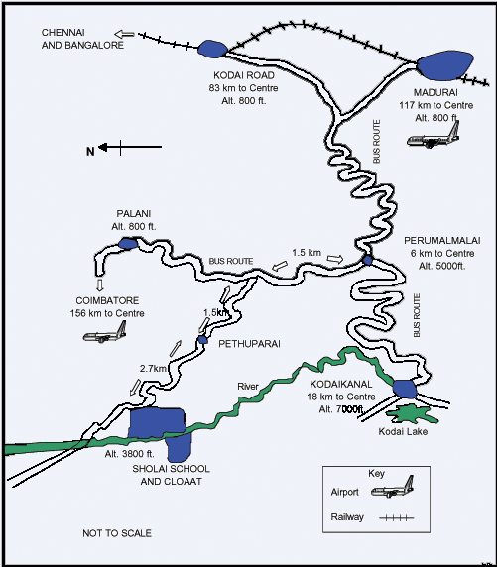
TO APPLY: Kindly send a passport-sized photo and a copy of your birth certificate and request an application form from:

contact@sholaischool.in

Or write to: The Principal,
CLOAAT, P.O.Box 57,
Kodaikanal - 624101, Tamil Nadu, India.

Tel.: 04542 230297/230393/230487

The application can also be downloaded from the website.

THE CENTRE FOR LEARNING, ORGANIC AGRICULTURE AND APPROPRIATE TECHNLOGY

MATURE STUDENT PROGRAMME



